**SA-BEST Engineering Notebook 2022**

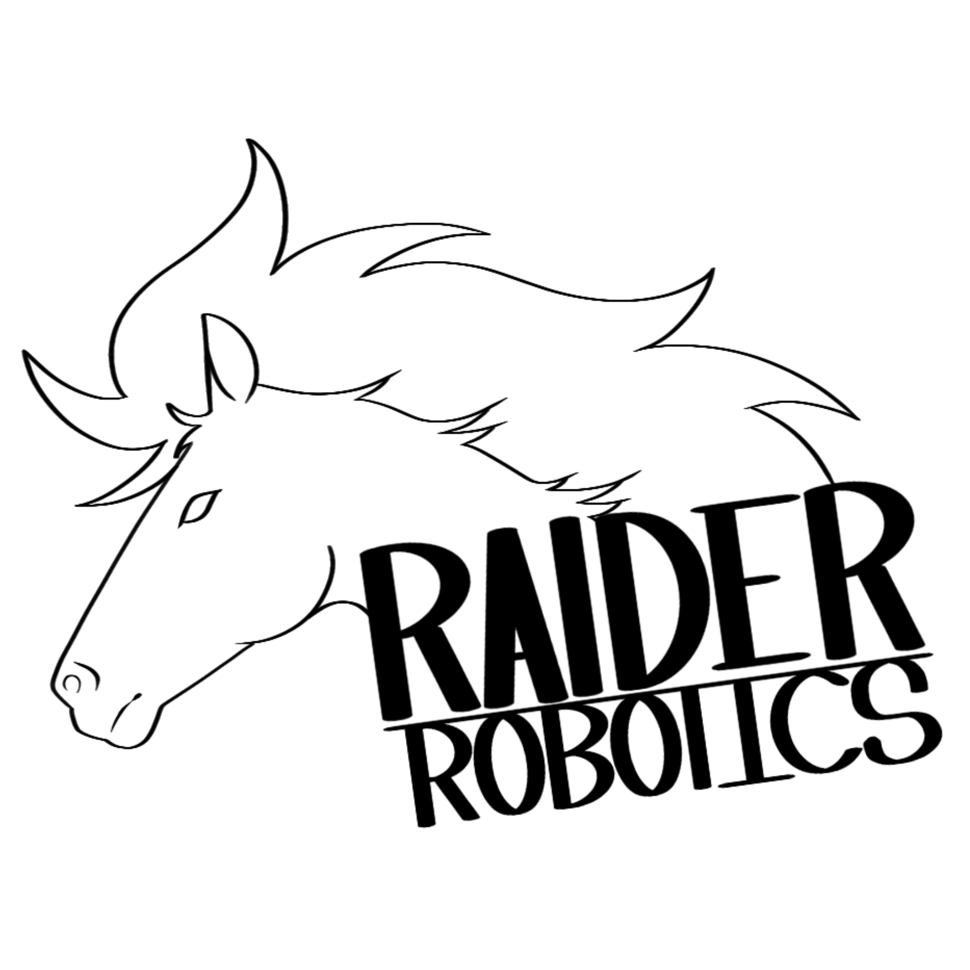

**Team Number:6**

**Donald Ellis, Teacher Michael Dickerson, Teacher**

**Telephone (210) 397-600 X3340 Telephone: (210) 397-6000 X3160**

**Email:**[**donald.ellis@nisd.net**](mailto:donald.ellis@nisd.net) **Email:**[**michael.dickerson@nisd.net**](mailto:michael.dickerson@nisd.net)



**Table of Contents**

Summary ………………………………………………………………………………………………..… 3

Research Paper …………………………………………………………………………………....… 4

Implementation of the Engineering Process …………….………………………… 7

Brainstorming Approaches ………………………..……………………………………….... 8

Analytical Evaluation of Design Alternatives ………………………………………. 9

Strategy Evaluation .……………………………………………………………………………….. 10

Offensive Strategy………………………………………………………………………….. 11

Defensive Strategy…………………………………………………………………………. 11

Safety…………………………………………………………………………………………..…………… 12

Software Design……………………………………………………………………………………… 12

Appendix …………………………………………………………………………………………………. 14

## **Summary**

## To effectively design and engineer our robot, “J.A.M.E.S” Joint Automated Mechanical Engineered System, we took careful planning of the team’s time into making sure each objective was made on the deadline (Figure 1), we also had separate teams to complete items while the full design was being made simultaneously. When the kickoff was over we made a prototype design as a team on what we wanted our robot to accomplish, having a mechanism to put the arm and battery on and to control the arm interface with only push and pull. We then made a section of the track to practice on, because we knew practicing would be the most integral part of the game. While the track was being built we worked together on making prototypes for the main parts of our robot and making changes along the way to what we found was best. After we had a base of what our robot was going to look like a programming team was created to work with the team and drivers on what was the best way to code the controller operations. Once we had a drivable prototype robot we focused our time on the best order type(s) and route that would be best for each driver, we used calculations and estimated scores of what would be most efficient to do, and we also tested multiple times of what item should be grabbed first and which way would save us the most time and was easiest for the driver.

## **Research Paper**

## In the past, we created robots with limited intelligence; it was up to the player's ability to command the machine. Today, robotic technology is now so advanced that computers are replacing human jobs. This is a part of the game's theme as we are building and designing a robot to control and assemble another robot in order to carry-out deliveries. Robots are advancing quickly and they are not as simple as they used to be. The probability that robots may replace humans is increasing. Computers are becoming more complex and we must understand the downfalls that will soon become a reality of advancing technologies.

## Back in 1913 -and towards the end of the second industrial revolution- engineers like Henry Ford wanted to fix the problem of high-cost machinery. In order to fix this, he’d have to increase factory efficiency. To do this, he developed an assembly line inspired by Ransom E. Olds, who was the original creator. Ford’s assembly line for vehicles decreased the time to make a car from 12 hours to 1 hour and 33 minutes. His more efficient assembly line used 84 incredibly distinct steps. Understanding technology's impact on the world can help us view how it links people together in more ways than one.

## In today's world assembly lines are very prevalent in the manufacturing industry, many factories have different versions of the assembly line. As an example, the company Tesla, uses assembly lines like Ford but instead of just humans working on it, they incorporated robots into the process as well. Tesla is a multibillion-dollar business, whose name is known by many for making expensive but enhanced electric cars. Their headquarters, the “Gigafactory'', which happens to be in Austin, Texas is where they use robots to produce their electric cars quicker and more precisely. The robots that they use to put the doors, battery, etc onto the vehicle are called an arm. Our prototype robot, J.A.M.E.S, is going to have similar arms to the ones in the Gigafactory. Each robot has a different job that they are designed for in the Gigafactory. Tesla's most famous model, the Model 3 was designed by humans, but is built mostly by robots. The reason they use these robots is to “do large jobs that are too dangerous for humans, or tasks which humans cannot do fast enough.”

## The advancement in technology can be a good thing, but may also have many bad consequences. Because of the advancement in technology “there are more unemployed and underemployed people in the manufacturing industry.” With these advances in robotics, robots are soon going to take over more and more human jobs. Parents are scared for their children to get jobs in the future. Some of the bad consequences of robots are potentially that they can replace humans in their jobs. In today's world, we have a variety of jobs to choose from, but that could change with these continuing advances in the development of robots. As people lose their jobs from robots it can result in more poverty, our economy could be split into two parts;those who benefit from making the robots and those who don't. In some cases, it could be more beneficial to have these advancements, for example, if you want to be in the engineering field there will be more job opportunities for you to take advantage of. The positive impacts that technology has on our society today are faster travel, better communication, finding information easier, and it is linking countries and people together on earth.

## Henry Ford made a huge impact on the start and growth of technology when he used assembly lines to make vehicles faster and more efficiently. From that point forward technology has improved dramatically to the point where robots in assembly lines make other robots such as vehicles, like Tesla. Now that technology is better than it used to be, we've had improvements and flaws.

## **Citations**

## History.com Editors. “Ford’s Assembly Line Starts Rolling.” HISTORY, 30 Nov. 2021, [www.history.com/this-day-in-history/fords-assembly-line-starts-rolling#:%7E:text=On%20December%201%2C%201913%2C%20 Henry,one%20house%20and%2033%20minutes](http://www.history.com/this-day-in-history/fords-assembly-line-starts-rolling#:%7E:text=On%20December%201%2C%201913%2C%20Henry,one%20hour%20and%2033%20minutes).

## “Technology, Jobs, and the Future of Work.” McKinsey & Company, 16 July 2019, <https://www.mckinsey.com/featured-insights/employment-and-growth/technology-jobs-and-the-future-of-work>

## Tesla, [www.tesla.com/giga-texas](http://www.tesla.com/giga-texas). Accessed 10 Sep. 2022.

## Wardynski, D. Technology, and Society: How Technology Changed Our Lives. 3 Aug. 2022, [www.brainspire.com/blog/technology-and-society-how-technology-changed-our-lives#:%7E:text=Technology%20has%20make%20it%20 easier,for%20 companies%20to%20do%20business](http://www.brainspire.com/blog/technology-and-society-how-technology-changed-our-lives#:%7E:text=Technology%20has%20made%20it%20easier,for%20companies%20to%20do%20business).

**Implementation of the Engineering Process**

First, we had to understand the problem and what we needed to do. We needed to build a robot that put parts onto the field robot and then use our robot to control the field robot to complete tasks. While looking at the problem there were a few items that were essential for us to complete, such as getting all four wheel mounts on and the battery, and the arm. The way we did these tasks was by strategizing and coming together to design a way we all agree. We came up with two main plans, we had a “U” shaped robot that was mainly used for pushing and a jump out claw. The other plan we made focused on height, having the robot tall enough to interact with the track, and tall enough to be level with the field robot. Then we would have to weigh the pros and cons between two plans, for example, for the jump out claw we thought would be too unstable and we could do more.. We ended up choosing a modified version of the second type, we found we were able to keep the height we wanted and create pulley systems and push mechanisms to interface with the track. At first, some of our thoughts and ideas didn’t go exactly as planned but as a team, we worked around that and made more prototypes that worked instead. We went through many prototypes for the arm to interface with the control box, we also made many changes throughout the design. Such as having to change the height and width of the pull mechanism to add stability. It is the same for the wheel mount mechanism. We started with having a soup can over the wheels to hold it. Instead we now have a cut out container to keep the wheel in place. We had meetings with the whole team to have each of us discuss our ideas at the end of the day and what we worked on so everyone knew (Figure 11). This helped when we split up to work on the arm and wheel mounts and at these meetings the members would explain what they made and how it works. Even though we had a confident design of the prototype components when testing we had to make many changes and create new ways our plan would work out best. After doing all this we had a more finalized design of our robot J.A.M.E.S (Figure 10), and set out into testing it more with the drivings to find improvement there, either something we could change in the code or an added feature.

**Brainstorming Approaches**

For our robot, we had three main parts to prototype and change to our liking and for its effectiveness. The first part we experimented with was the arm interface, our prototype ended up having too big of an angle to properly grab the lever and was too long. We went through several designs and used different math to calculate how steep the angle should be to properly connect to the lever. Our design had to become smaller and more curved to accommodate what we wanted to do. We ended up with an outcome that when pushed to the pole it would snap to connect it from the rubber band holding it because we saw that this would be the most effective way to get ahold of the lever. The next part we had to figure out how to design was the mechanism for putting the battery, wheels, and arm on the Field Robot. We first came up with a design for the wheel mounts, where it would have a stack of wheels on it and we would slide the holder out from on top of it so the magnets would stick it on. We then expanded that idea by connecting a pulley system to it as an easier way to pull it out than driving, and by adding another pulley system to do the arms and battery placement (Figure 6). The final major part that we had to design was the IR Sensor placement and design. We decided on having the IR sensor be 5 in from the floor to the bottom of the robot because that aligned with the sensor on the control box. We found that we had to make an encasing for it to protect the sensor and to have a place to put the servos. We had originally put it on the top of the robot but we found problems with the height of the robot and how it was more vulnerable to being hit at the top. For the original design of it we had intended for the sensor to rest on the bottom of the robot base, but found it was best with having the sensor face straight to the control box having us change our design to make the sensor fit like a pocket in the front (Figure 7). For our driving alternatives, we found that each driver is different, and was best to do their order type for each person. At first, we had a strict order of items to be grabbed to save time, but it was found other drivers had better methods for orders of grabbing the items.

**Analytical Evaluation of Design Alternatives**

We calculated the amount of time it took for the field robot to get to the end of the track, which turned out to be 8.11. We then used this time to calculate how long it would take to grab each item and the best route, where the driver could get the most items and then go back to put them in the box. We then calculated the rough estimates of points we would get from putting it all together. We found with the 1.4 multipliers and doing the Spares and Expansion order type we and the other items would have a score of 330. However, some drivers we found could do better and do the full robot which gained them 500+ points, we found that even with drivers doing different order types we still get a significant score. We also calculated the amount of time estimated to finish setting up the robot before driving the field robot (Figure 8). We have many different routes calculated for each of the drivers' order completion. For the arm interface, we couldn’t make our mechanism more than 4 inches as that would be too big for the rubber band to properly work. We changed the angle from the original one of not having an angle, to steadily going steeper till we got to 48°. We have it at this angle because we calculated how this angle had the most amount of tension/hold on the pole once released. Another change made was the change from the inner cut out to being 6 into 4 in because we found out we had to have exactly the pole's width cut out.

**Strategy Evaluation**

The first step of our strategy is once the spotter has put on the wheel, battery, and arm, our robot will drive to the boxes with no handles and place it to the right of the control box. Next, the robot will place the components onto the field robot, then depending on whether the driver can do multiple orders or not, the robot will push a box with a handle in between the servos and wheel. The driver will then line themselves up and complete the orders they know, at the end the spool will be pushed off for bonus points.

**Offensive Strategy**

As we did not have to focus much on a defensive strategy, we focused mainly on the offensive. With our design of building all of the field robots at a quick pace, we easily pick up the multipliers while others won’t. Another major offensive strategy we have is the software ability to only have to use one lever, this ability allows us to react faster than opponents when completing the orders. It was designed for the drivers to be able to mimic the control box from the controller. For the game having the multiplayer advantage and the speed adjustment greatly helps us in gaining more points than other teams.

**Defensive Strategy**

With the way the field is set up, only when you head to the middle for the boxes do you encounter other teams, with very little robot interaction there is not much need for a defensive strategy. The only thing that needs to be protected is the underground wiring as it is possible when pushing the boxes we could mess with our sensor and the wires on the bottom. With the game being reliant on speed and driving we made a high and sturdy base with hollow support joints filled with a counterweight to help balance.

**Safety**

Each team member had to pass a series of tests for each piece of machinery and how to properly use it. When the first meeting day, and when new members came, the mentors explained how to use each of the tools safely and when asked would show us how to reuse a tool safely. We made sure to always follow safety guidelines of having long hair tied back, wearing safety glasses, wearing closed-toe shoes, and always having another person supervise you while working at a machine. We always had mentors available who knew how to handle each machine we worked on to ask questions or concerns. At the end of each meeting, we are sure to take time to clean our stations of sawdust and metal shavings. When working with anytype of macherary from drills to sanders we made sure to always wear protective eye glasses. When we worked with spray paint we were sure we were in a well ventilated area and how to properly dispose of contaminated rags.

**Software Design**

For the objective of the coding, we wanted to implement the IR sensor on the robot to tell what the IR sensor on the control box does. We came up with the idea to use buttons on the controller to send out specific hexadecimal codes to command the field robot (Figure 2). It was also found that the code could be made to only have to use one arm interface instead of three, the driver would press a button which sends an IR sensor code through the IR sensor and we then would be able to use the middle arm to control everything we needed. We had to test the sensors various times and found a problem where sometimes it wouldn’t line up and not send out the command, so on our robot, we made indents to always line up the sensor. With only having to use one arm we decided to change our previous idea of using buttons to control the arm interface but used the other joystick. We tested the idea of using buttons instead and found it was much easier to drive and gave the drivers more control, the drivers already had experience in arcades so it was preferable to them to have one joystick control the whole thing instead of two. In the code, we originally had no wait time (Figure 3 -Line 68) for each button but then found the command went too fast for our hand to come off making the command send multiple times. We had multiple test runs of the coding as we found many problems and updates to be made, such as the driving being backward (Figure 4) and more button controls being added. Other designs for the code were thought such as the controlling of “Squeaky” making the order fully autonomous, but it was found to have too many calculations and too many uncontrollable variables in the field. We made sure that as we were testing all these new ideas to have backups of the coding we already had. We got the conclusion of what the commands for the robot should be after multiple test drives and a discussion of efficiency in the placement.

**Appendix**

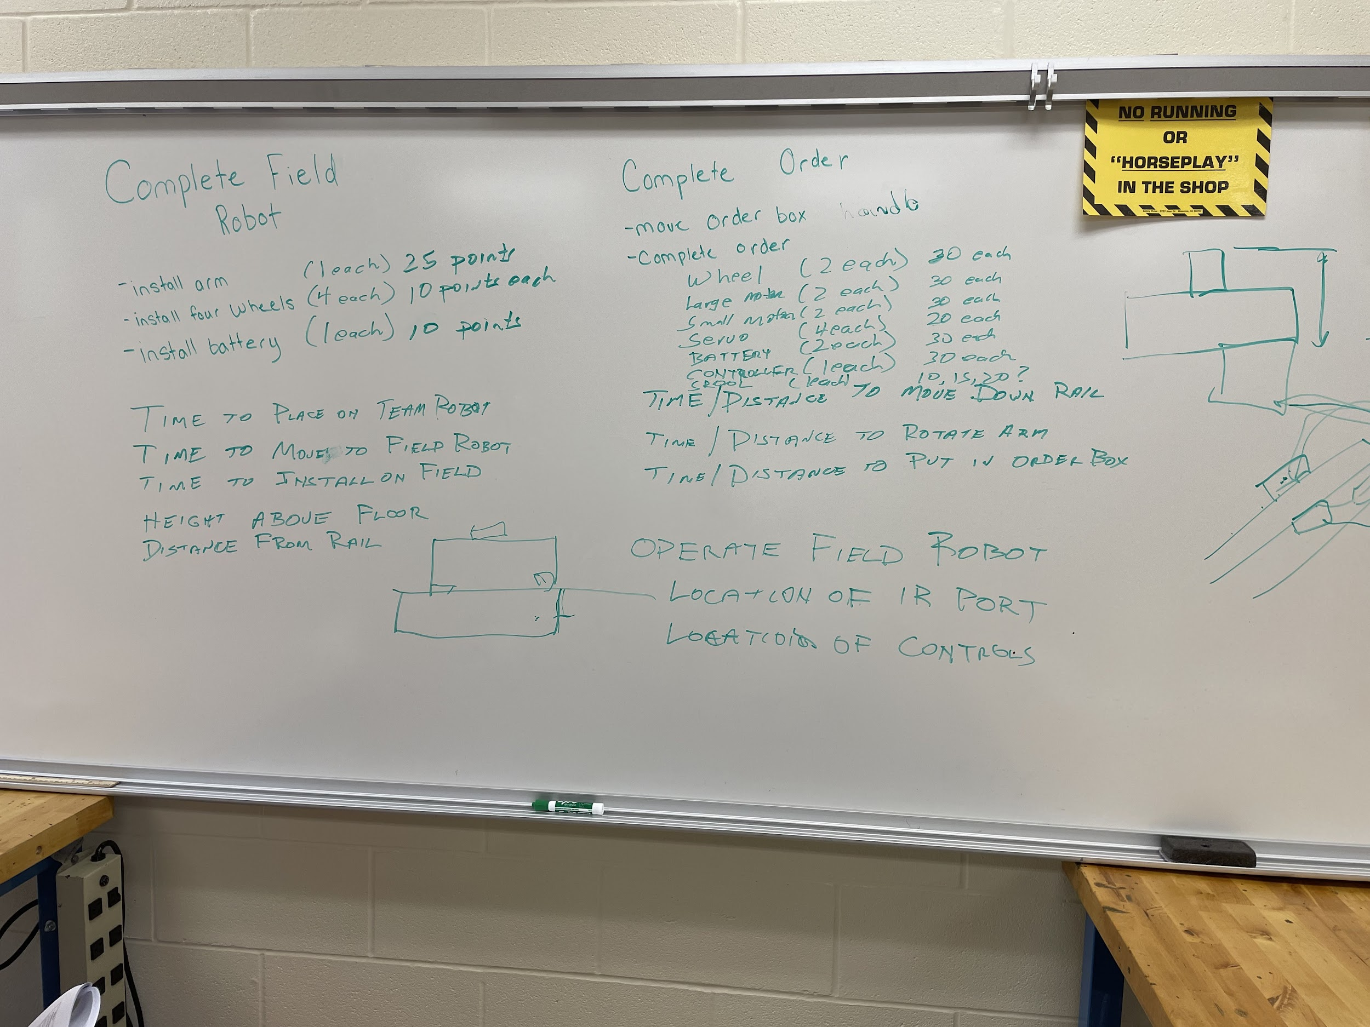

Figure 1: The board shows our objectives

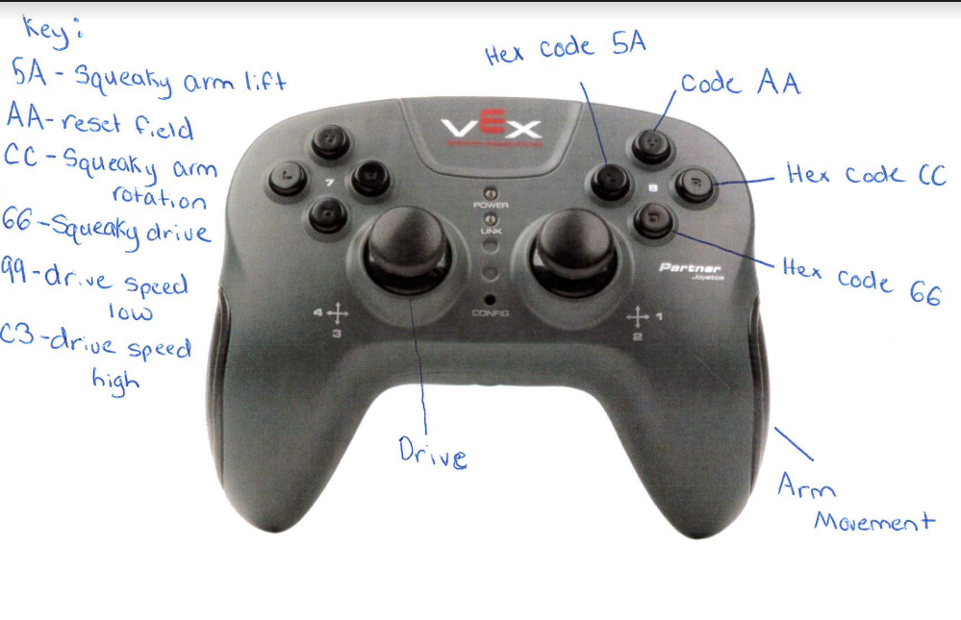

Figure 2: Controller Operations

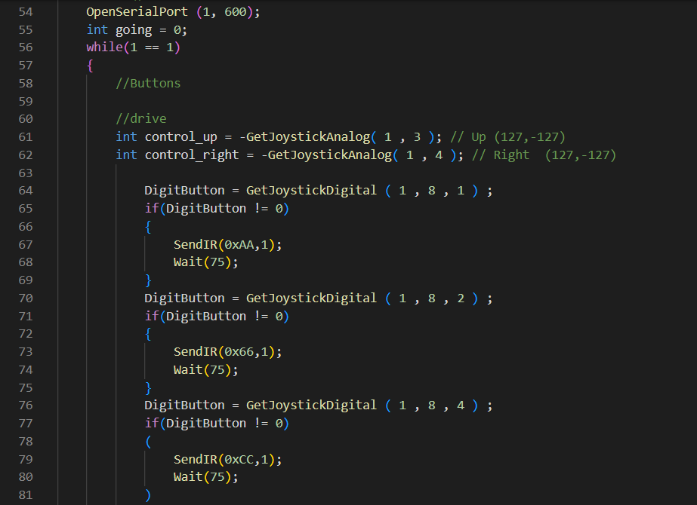

Figure 3: Portion of the code showing the button commands

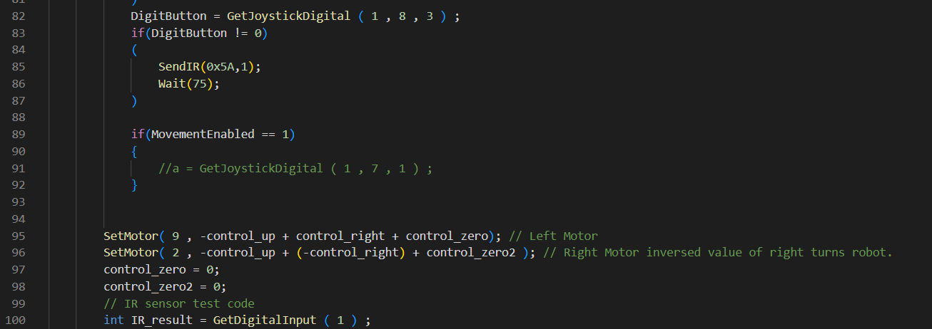Figure 4: Portion of the code showing driving controls

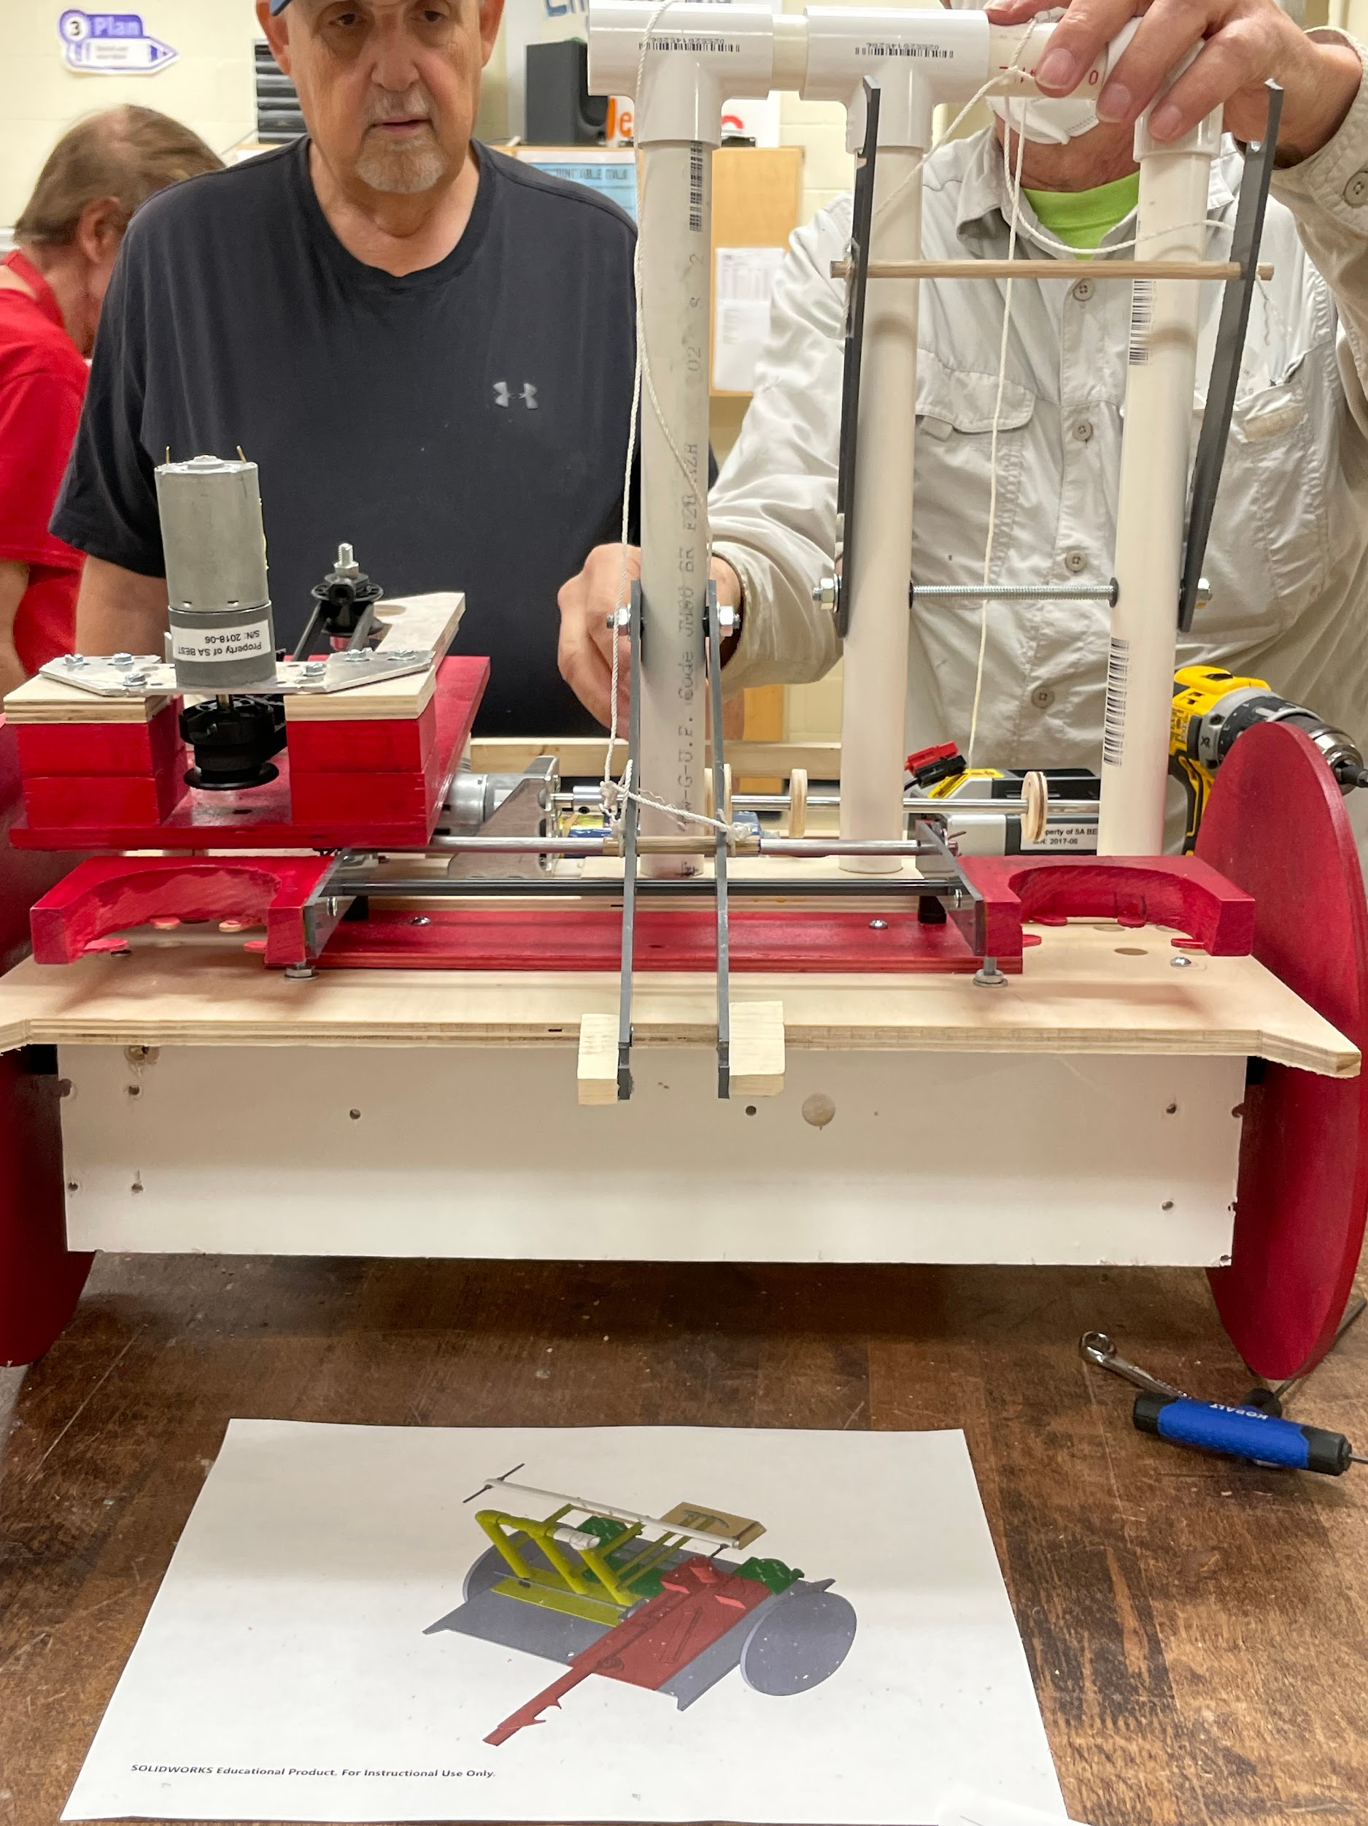

Figure 6: View of battery, arm, and wheel mechanisms

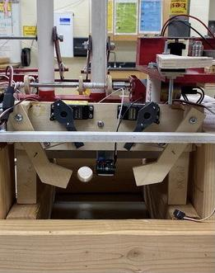

Figure 7: View of the IR sensor container

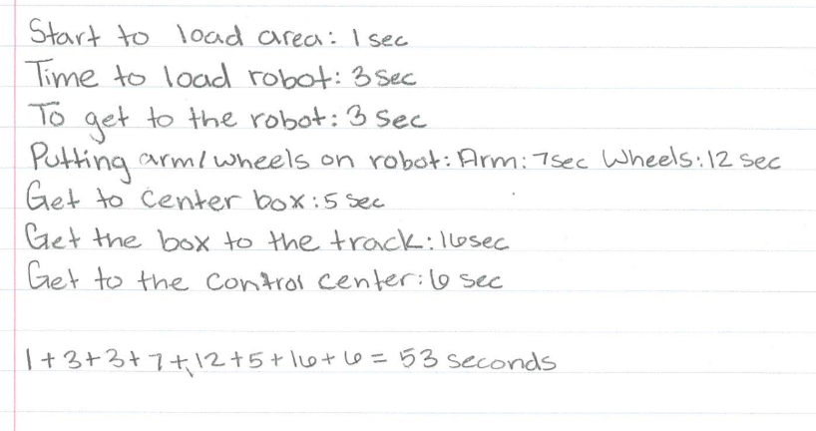

Figure 8: Calculations of the driving time

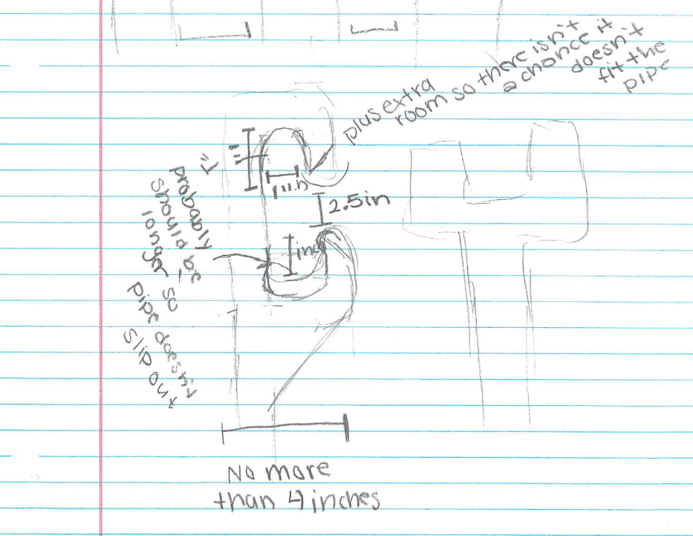

Figure 9: First Prototype of our arm interface

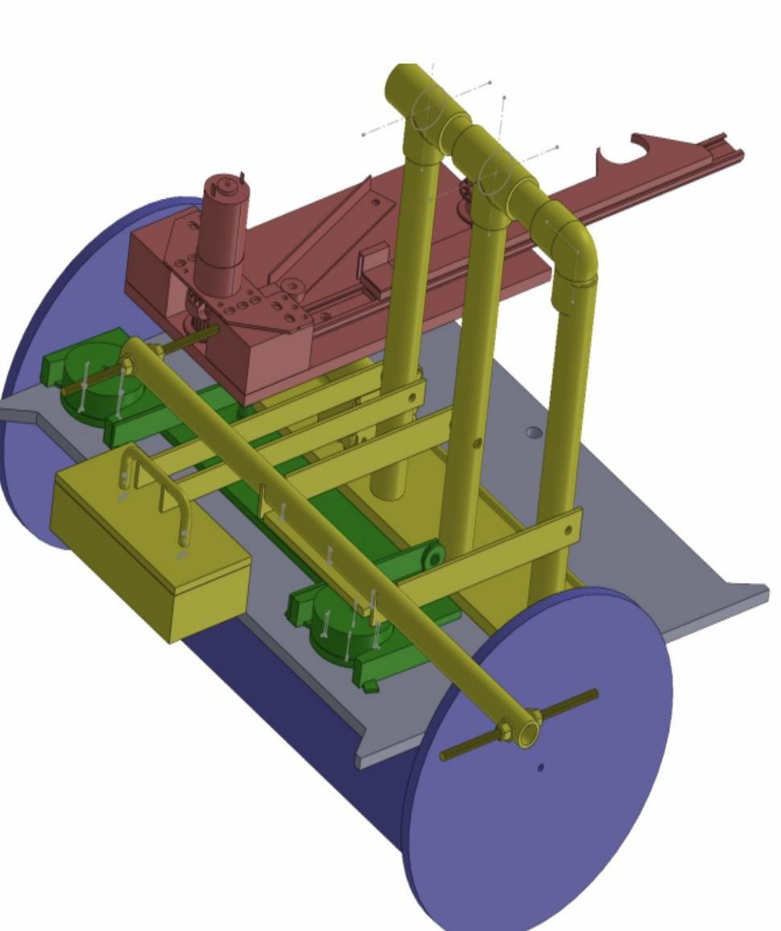

Figure 10: CAD Drawing of the robot with arm, battery, and wheel holders on

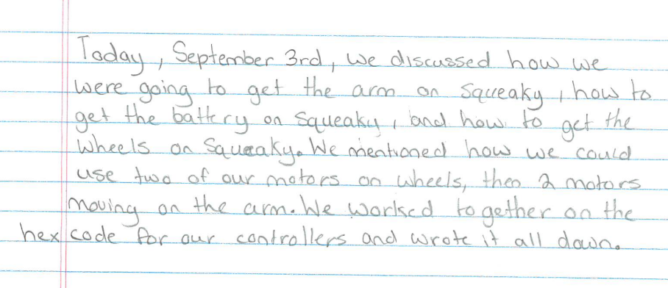

Figure 11: One example of a days meeting notes